**Henstridge Health Walks** 

**Route One**

Start at village hall. The entire walk is on asphalt/concrete except where stated.

Ash Walk, cross at lights to Shaftesbury Road; New Station Gardens; part of old railway line (packed sand); Blackmoor Lane; Brook Lane; Vale Street; The Cross; Church Street; footpath through churchyard; Church Street; footpath to St. Nicholas Close; Park Road; Ash Walk to village hall. 1.1 miles.

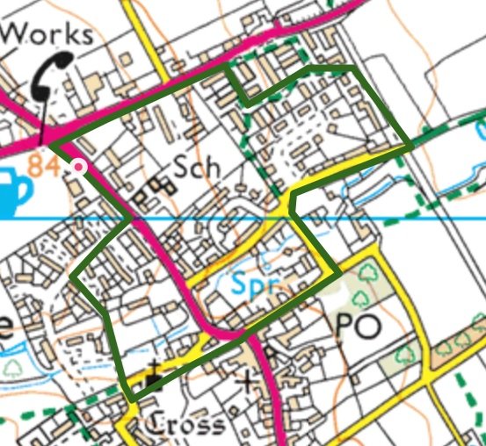



**Risk Assessment Form**

|  |  |  |  |
| --- | --- | --- | --- |
| **Walk location** | Henstridge Route 1 | **Date** | 7/11/2018 |

|  |  |
| --- | --- |
| **Assessment carried out by** | Paul Heyes |

| **Hazard** | **Who might be harmed** | **How is the risk controlled** |
| --- | --- | --- |
| **Traffic/roads**  Whole route except footpath sections | All walkers | * Warn walkers in pre walks talk * Cross at safer places (e.g. zebra crossings) * Extra care at The Cross * Keep group together * Wear luminous tabards |
| **Dogs mess** | All | * Warn in pre walk talk * Warn as necessary on route |
| **Dogs** | All, particularly children and those fearful of dogs | * Warn in pre walk talk and as necessary on route * Keep nervous walkers away from dogs |
| **Over hanging branches** | All | * Warn in pre walk talk and as necessary on route. |
| **Weather**  Sun  Rain  Cold | All, particularly those that are not dressed appropriately | * Check walkers’ clothing at beginning of walk * Take water, hats, rain coats, etc. * Be aware of places to shelter * Cancel walk if necessary |
| **Other people**  e.g. Children in the park  bikes on the pavement or in the park | All | * Keep walking group together * Be considerate of others - avoid blocking entrance ways and paths * Move past any potentially threatening group avoiding eye contact * Carry an attack alarm, should you feel there is cause to do so. * Have a charged mobile to hand |
| **Slips, trips and falls**  Kerbs slippery when wet and are a step up for a pushchair whilst crossing the road. Wet leaves in autumn; ice in winter. | All walkers particularly those with balance difficulties/mobility issues | * Warn in pre-walk talk and as necessary on route * Help walkers around muddy spots, narrow paths, etc. * Alter route if path accessibility is very bad |
| **Inclines**  Blackmoor Lane, Brook Lane, Vale Street: shallow (1 in 40) | All walkers, particularly those with heart problems e.g. Angina | * Warn in pre-walk talk * Be aware of walkers’ health needs * Allow everyone to take inclines at their own pace * Remind walkers to take and use medication if necessary * Rest at hill tops and wait for group |
| **New walkers** | All, particularly the new walker | * Read through health check questionnaire with the new walker * Share relevant disclosed health information with other leaders * Be extra vigilant whilst walking * Buddy new walker with a regular walker or another walk leader * Accompany the new walker back to base if necessary |
| **Other** | | |
|  |  |  |