SUMMONS
You are summoned to attend the next meeting of Henstridge Parish Council at the Henstridge Village Hall Lounge on Monday 4th February 2019 from 7.30pm until 9.30pm.

AGENDA
Members are reminded that the Council has a general duty to consider the following matters in the exercise of any of its functions: The Code of Conduct, Equal Opportunities (race, gender, sexual orientation, marital status, age and any disability), Crime and Disorder, Health and Safety and Human Rights.

The meeting will commence after there has been an opportunity for members of the electorate of the Parish to speak. In normal circumstances this will be restricted to approximately 15 minutes in total and shall be at the Chairman’s discretion.
Please note, items raised by the public in this session will not be discussed by the council and will not be minuted. Items for inclusion on the agenda should be put to the Clerk in writing prior to the meeting as listed in the final item.

- Apologies for absence.

- Declarations of interest.

- To approve as a correct record the minutes of the previous meeting held on 07/01/19.

- Reports
- To receive any Police matters.
- To receive County and District Councillor reports.

- Recent SSDC Area East planning decisions:
 | Application number | Proposal | Applicant details | Current status
a) | 18/02576/FUL | The conversion and change of use of existing farm buildings and land to a Children's Day Nursery (Use Class D1) including erection of covered play area, new vehicular access and track and associated car parking. | Trustees Of Inwood Land Settlement No. 2, Manor Farm, High Street, Yenston.  BA8 0NF | Granted with conditions
b) | 18/02853/HOU | The erection of conservatory | Mr Gabriel Swatzell, Little Acre, 7, Meadow Close, Henstridge. BA8 0SY | Granted with conditions
c) | 18/03765/HOU | Erection of two storey side extension, single storey rear extension and conversion of the garage into habitable accommodation. | Mrs Sarah Barnes, Border Cottage, Landshire Lane, (East), Henstridge. BA8 0SD | Granted with conditions

- Other planning matters
- To note that the Clerk had received a telephone call from the builder working at 52 Ash Walk (planning application 17/02712/FUL), confirming that the Parish Council’s list of additions to the construction management statement would be observed.
- To note that the Police had attended the development site in Furge Lane and found that no laws had been broken in respect of any badgers on or near the site.
- To note receipt of several emails from a resident regarding the Furge Lane development requesting that the Parish Council takes action to ensure that the amenity space on the site remains as an amenity space and also to explain why it did not write to SSDC to support the resident’s views with regard to badger runs and setts on and near the site.
- To note comments from the planning officer regarding the drainage scheme for the Furge Lane development and to agree any further comment or action to take.

- Council Matters
- To note that the Parish Council’s insurance would not cover any activities or events organised by the Events Group or any other group separate from the Parish Council.
- To note receipt of two letters from residents regarding recent flailing at the Recreation Ground and to consider a response.
- To consider a request from a resident for the siting of new memorial bench and plaque at the Recreation Ground near the shed; to consider the requested inscription for the plaque; to consider how to prepare the location and the style of bench to be sourced.
- To note that the Parish Council’s historic records have been deposited with the South West Heritage Trust.
- To note that the Village Hall Management Committee is seeking a feasibility study to assess the suitability of the roof of the Village Hall for the installation of solar panels.
- PROPOSAL from David Nichols: That the Clerk is instructed to find out about SSDC’s Parish Ranger Scheme, including availability and cost, to deal with various jobs around the Parish.
- To discuss any other outstanding highways issues or highways matters which councillors wish to raise and agree any actions arising.
- To hear any matters arising from playground, skate park and green gym inspection reports.
- To receive reports from representatives (VHMC, Footpaths, Tree Warden, CSW, Youth, Other) and provide guidance as appropriate

- Finance
  - To note the third quarter budget sheet.
  - To agree two bank signatories to sign a form to close the Project account.
  - To note that SCC has provided a price of £2800 to install white gates in Yenston and that the Clerk will apply for a grant from Avon and Somerset Police’s Road Safety fund.
  - To consider a request for funding towards the cost of The Somerset Wood, a WW1 memorial project.
  - To consider a request for a grant from Yeovil Shopmobility.
  - To consider a price for 13 additional email addresses for members from the Parish Council’s email provider at a total cost of £65 per year.
  - To approve the cashbook and bank account reconciliations for the deposit account to 5th December 2018 and the current account to 27th December 2018 as presented.
  - To approve the following accounts for payment and two signatories for cheques:-
Minute ref | Supplier/Contractor | Narrative | Amount
11b) 04/07/16 | NEST | Staff pensions | £53.21
11f) 04/07/16 | bOnline | Village Hall broadband Dec 2018 | £29.62
 | Staff | Salary January 2019 | £1081.08
 | Staff | Salary January 2019 | £81.39
 | HMRC | Tax & NICs January 2019 | £192.51
 | Staff | Salary January 2019 | £42.68
 | Staff | Expenses January 2019 | £98.75
11d) 07/01/19 | SALC | Essential Clerk’s training | £85.00
 | Barvick Engineering | Supply and fit replacement bus shelter glass | £234.00
 | T J Young | Service 2 x mowers, strimmer & hedge trimmer | £346.18
 | Stalbridge Building Supplies | Replacement gate latch | £6.35

- Exclusion of Press and Public: To consider exemption of press and public for remainder of meeting under Public Bodies Admissions To Meetings Act 1960, Section 1 (2) on the grounds that discussion of the following business is likely to disclose confidential information.

- To hear an update regarding the working party that is dealing with a personnel issue. (HB-M)

- Date of Next meeting – The next Parish Council meeting will be held on Monday 4th March 2019. All items for inclusion on the agenda and all items to be listed under issues arising from previous meetings must be received by the Clerk by 9.00am on Thursday 21st February.
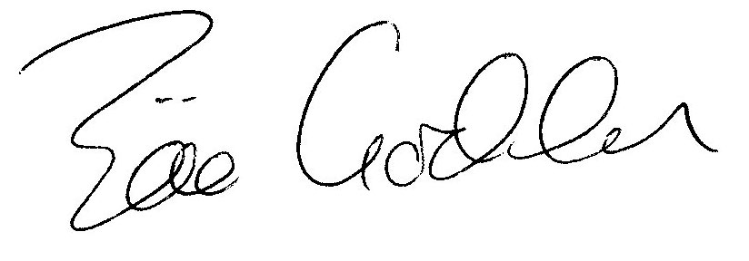
Zöe Godden
Parish Clerk

