SUMMONS
You are summoned to attend the next meeting of Henstridge Parish Council at the Henstridge Village Hall Lounge on Monday 4th March 2019 from 7.30pm until 9.30pm.

AGENDA
Members are reminded that the Council has a general duty to consider the following matters in the exercise of any of its functions: The Code of Conduct, Equal Opportunities (race, gender, sexual orientation, marital status, age and any disability), Crime and Disorder, Health and Safety and Human Rights.

The meeting will commence after there has been an opportunity for members of the electorate of the Parish to speak. In normal circumstances this will be restricted to approximately 15 minutes in total and shall be at the Chairman’s discretion.
Please note, items raised by the public in this session will not be discussed by the council and will not be minuted. Items for inclusion on the agenda should be put to the Clerk in writing prior to the meeting as listed in the final item.

- Apologies for absence.

- Declarations of interest.

- To approve as a correct record the minutes of the previous meetings held on 04/02/19 and 18/02/19.

- Reports
- To receive any Police matters.
- To receive County and District Councillor reports.

- To consider the following planning applications:
 | Application number | Proposal | Applicant details
a) | 19/00281/DPO | Application to modify a Section 106 agreement between Losan Limited, Henstridge Airfield Partnership No. 2 LLP, EGHS Limited, Mr Geoffrey Charles Jarvis and South Somerset District Council dated 05.12.2017 to include a restriction that No Helicopters shall take off from, or land on, the Land for the purpose of, or after, pilot training within a 5 mile radius of the airfield. | Geoff Jarvis, Henstridge Airfield, The Marsh, Camp Road, Henstridge.
b) | 19/00183/FUL | Erection of workshop building for the fabrication of agricultural livestock feed silos. | Mr Nigel Jeans, N D Jeans Engineering Ltd, Henstridge Airfield, The Marsh, Camp Road, Henstridge.
c) | 19/00314/S73 | Section 73 application to vary conditions 1, 2, 6, 9, 12, 13 and 14 of 15/04069/FUL for continued use as airfield and recreational use subject to conditions and a S106 agreement. | Geoff Jarvis, Henstridge Airfield, The Marsh, Camp Road, Henstridge.

- Recent SSDC Area East planning decision:
Application number | Proposal | Applicant details | Current status
18/01931/COU | The use of part of the building as residential accommodation for facilities manager (Retrospective) | Henstridge Golf and Leisure, The Club House, Henstridge Sports and Leisure Centre, Marsh Lane, Henstridge. BA8 0TG | Granted with conditions
- Council Matters
- To consider a request from Explorers Preschool to use the Recreation Ground for an Easter event for children on Friday 19th April (Good Friday).
- To consider allowing the Clerk to attend a free Clerk’s Briefing event run by SALC on Friday 12th April.
- To note that the Clerk has arranged to meet with SSDC regarding clearance of the concrete benches and shed base at the Recreation Ground.
- To consider giving permission, in principle, for the Village Hall Management Committee to use the roof of the Village Hall for solar panel electricity generation, the final decision to be made on receipt of a feasibility study.
- To consider a request from the Parish Events Group to hold a summer event at the Recreation Ground on Saturday 27th July.
- PROPOSAL from Peter Croker: That County Highways are approached to request the installation of safety fencing at the crossroads of the A30 and A357, following a recent collision between a lorry and a post at this location.
- To consider arrangements for the Annual Parish Meeting, taking place on Wednesday 29th May.
- To hear an update regarding arrangements for the next Be Home Safe event.
- To receive a draft of new terms of reference for the Open Spaces Committee.
- To consider how to review the role and constitution of the Personnel Committee.
- To discuss any other outstanding highways issues or highways matters which councillors wish to raise and agree any actions arising.
- To hear any matters arising from playground, skate park and green gym inspection reports.
- To receive reports from representatives (VHMC, Footpaths, Tree Warden, CSW, Youth, Events Group, Other) and provide guidance as appropriate

- Finance
  - To note that the project account has been closed as instructed (minute reference 12b) 07/01/19).
  - To consider a request for funding towards the cost of The Somerset Wood, a WW1 memorial project, based on a cost of £25 per tree.
  - To consider purchasing a copy of the 11th edition of “Local Council Administration” by Charles Arnold-Baker at the discounted price of £103.99 (full price is £129.99).
  - To approve the cashbook and bank account reconciliations for the deposit account to 18th January 2019, the current account to 24th January 2019 and the project account to 14th February 2019 (on closure) as presented.
  - To approve the following accounts for payment and two signatories for cheques:-
Minute ref | Supplier/Contractor | Narrative | Amount
11f) 04/07/16 | bOnline | Village Hall broadband Jan 2019 | £29.62
11b) 04/07/16 | NEST | Staff pensions (Jan & Feb 2019) | £106.42
 | Staff | Salary February 2019 | £1081.08
 | Staff | Salary February 2019 | £81.39
 | HMRC | Tax & NICs February 2019 | £192.71
 | Staff | Salary February 2019 | £42.68
 | Staff | Expenses February 2019 | £117.60
10c) 05/03/18 | Milborne Port Computers | LiveDrive back up annual fee | £48.00
11c) 05/02/18 | Somerset County Council | Installation of white gates and associated signage and road markings | £2017.74
10f) 04/12/17 | Scribe | Accounting software 2019-20 | £339.60
 | Michael Player | Mileage re CSW | £56.25
8e) 04/02/19 | Yeovil Shopmobility | Grant | £40.00

- Date of Next meeting – The next Parish Council meeting will be held on Monday 1st April 2019. All items for inclusion on the agenda and all items to be listed under issues arising from previous meetings must be received by the Clerk by 9.00am on Thursday 21st March.
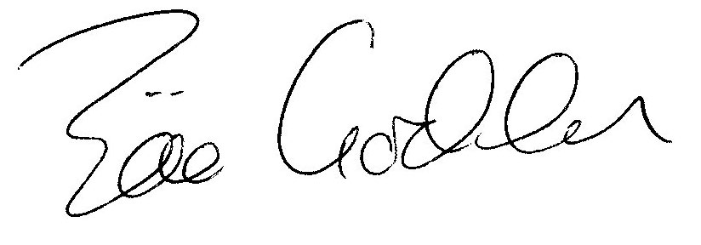
Zöe Godden
Parish Clerk

